GUIDELINE IMPORT LIBRARY

1. Create Project

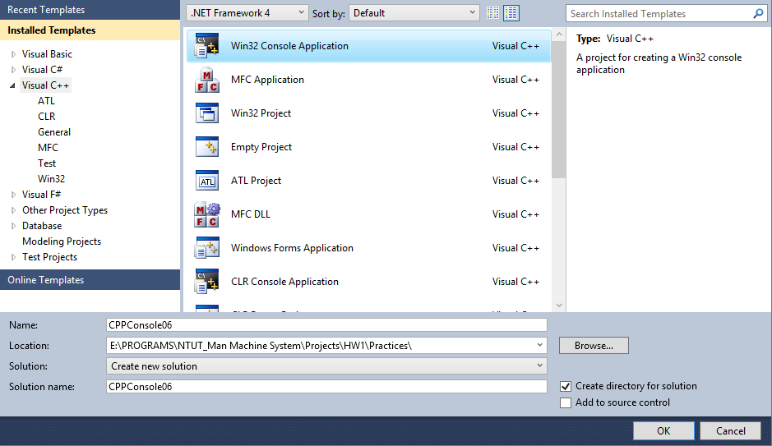

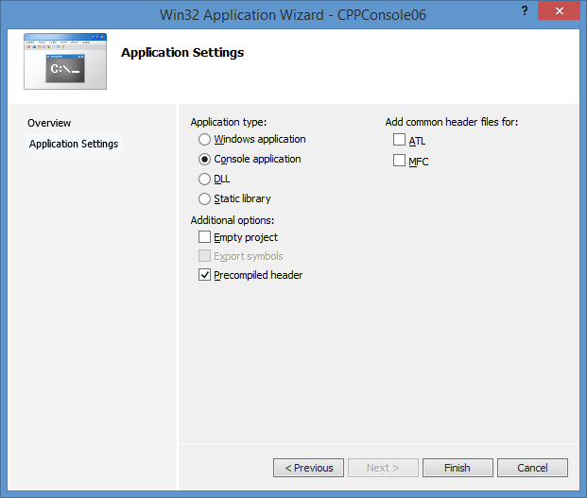

1. Import Image Library
2. Config stdafx

* Open file stdafx.h, add these lines in the end:

#if !defined(AFX_STDAFX_H__D88208E8_D981_4C7E_B9C8_9F578E6A2853__INCLUDED_)

#define AFX_STDAFX_H__D88208E8_D981_4C7E_B9C8_9F578E6A2853__INCLUDED_

#if _MSC_VER > 1000

#pragma once

#endif // _MSC_VER > 1000

#define VC_EXTRALEAN // Exclude rarely-used stuff from Windows headers

#include <afxwin.h> // MFC core and standard components

#include <afxext.h> // MFC extensions

#include <afxdisp.h> // MFC Automation classes

#include <afxdtctl.h> // MFC support for Internet Explorer 4 Common Controls

#ifndef _AFX_NO_AFXCMN_SUPPORT

#include <afxcmn.h> // MFC support for Windows Common Controls

#endif // _AFX_NO_AFXCMN_SUPPORT

//{{AFX_INSERT_LOCATION}}

// Microsoft Visual C++ will insert additional declarations immediately before the previous line.

#endif // !defined(AFX_STDAFX_H__D88208E8_D981_4C7E_B9C8_9F578E6A2853__INCLUDED_)

* Config project:

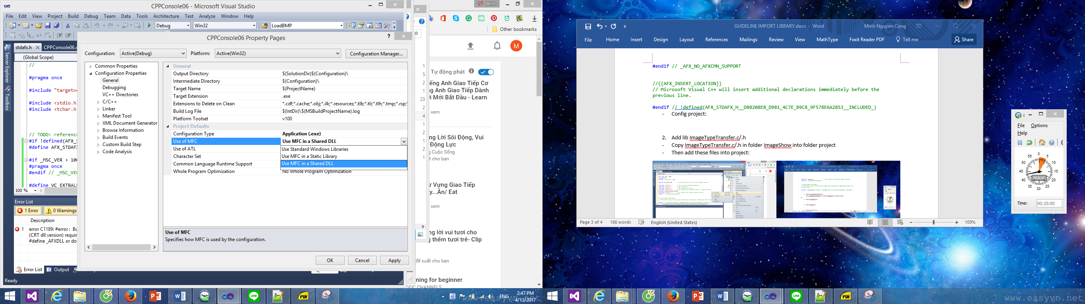

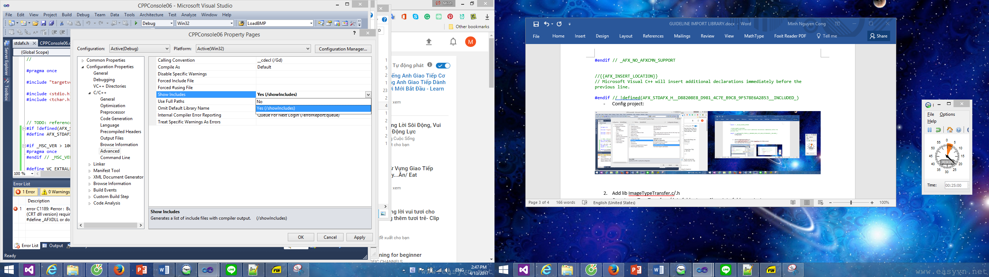

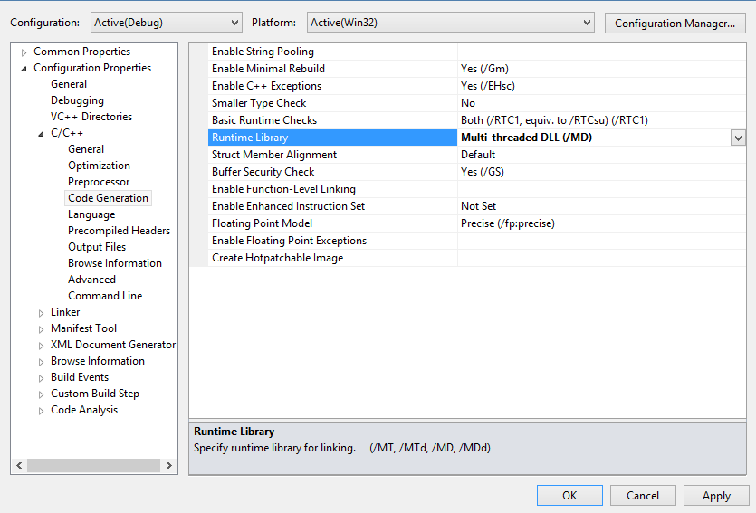

1. Add lib ImageTypeTransfer.c/.h

* Copy ImageTypeTransfer.c/.h in folder ImageShow into folder project
* Then add these files into project:

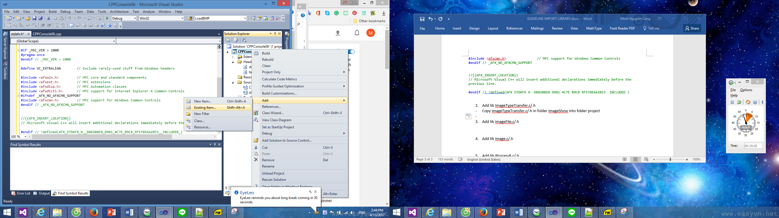

* Add line:

#include "ImageTypeTransfer.h"

at the end of file stdafx.h

1. Add lib ImageFile.c/.h and ImageFile.c/.h at the same time

* Copy ImageTypeTransfer.c/.h in folder ImageShow into folder project
* Add those files into project
* Add line:

#include "Image.h"

#include "ImageFile.h"

into stdafx.h

1. Add lib IProcessB.c/.h and IProcessC.c/.h

Do similar to above step: copy file => add file into project => add #include line

And add: #include <math.h>

1. Add lib IProcess.c/.h and IProcessD.c/.h

Do similar

1. Add lib IProcessE.c/.h

Do similar

1. Add lib IProcessF.c/.h

Do similar

1. Add lib CreatePal.c/.h

Do similar